The Salt and the Sea: The Life of Christos D Matsiras
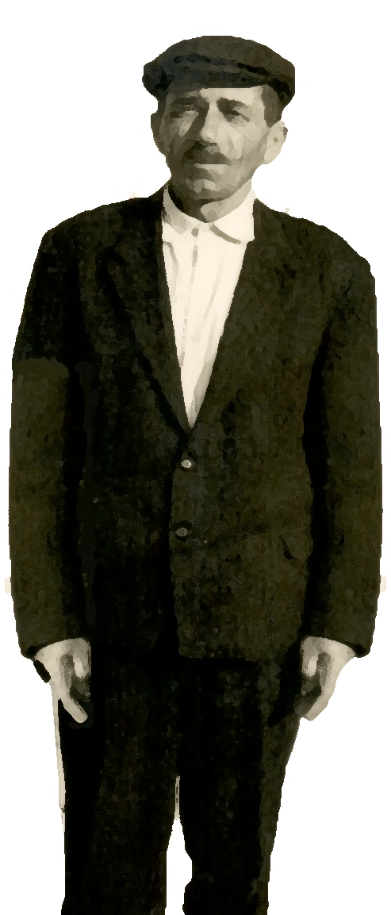
Drawn from audio interviews with my
Pappou, this biography is a tribute to the
extraordinary lives of my grandparents.

Their strength during challenging times,
their ethical example, and their
unwavering belief in me shaped my
difficult childhood and continue to
inspire me today.

With deepest gratitude, I dedicate this story
to them.

Paul V Matsiras, PhD
January 1, 2025

Table of Contents
Chapter 1 — The Shadow of the Crescent Moon 1
Chapter 2 — Flight from the Ashes 2
ChaPter 3 — A Mother’s Embrace 3
Chapter 4 — A Father's Legacy 4
Chapter 5 — The Shadow of Mytika 5
Chapter 6 — A Fleeting Kindness 6
Chapter 7 — The Open Sea 7
Chapter 8 — The Fish Farm's Solitude 8
Chapter 9 — Bandits and Bargains 9
Chapter 10 — An Empty Feast 10
Chapter 11 — A Fish Story 11
Chapter 12 — A New Family 12
Chapter 13 — Finding Purpose in Work 13
Chapter 14 — A Boat and a Betrayal 14
Chapter 15 — Smuggler's Run 15
Chapter 16 — A Quiet Act of Courage 16
Chapter 17 — War and Worry 17
Chapter 18 — A Double Blow 18
Chapter 19 — A New Beginning 19
Chapter 20 — Family and Future 20
Chapter 21 — A Legacy of Strength 21

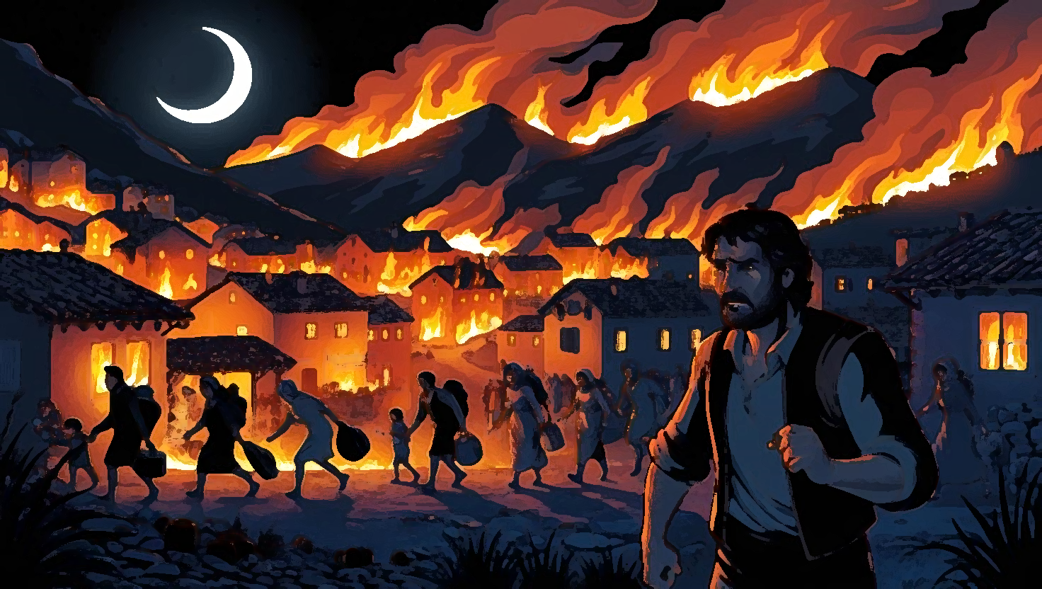

Chapter 1 — The Shadow of the Crescent Moon
The year is 1803. Greece groans under the Ottoman yoke. In the remote, craggy mountains of Epirus, two families, the Koutsonikas and the Gerokostas, stand defiant against the Turkish tide. But the whispers of rebellion turn to desperate flight. Hunted like animals, they escape through Zaloggo in 1804, seeking refuge first in Parga, then besieged Messolonghi. When Messolonghi falls in 1826, the surviving protopalikara (best fighters) of Markos Botsaris, along with their families, return to the smoldering embers of Souli. They find a precarious sanctuary in Karakoli, a village clinging to the mountainside, already embroiled in its own desperate struggle. The Koutsonikas name, now hardened by necessity, has become Matsiras – Albanian for "murderer" (of Turks).
The air in Karakoli choked with the acrid stench of burning wood. The distant thud of cannon fire echoed through the valleys, a constant, ominous drumbeat. Children, too young to understand the complexities of war, clung to their mothers' skirts, their wide eyes reflecting the flickering flames. "Mama," they whimpered, burying their faces in roughspun wool. "Will the Turks hurt us?" The mothers, their faces etched with worry, forced strained smiles. "No, my little sparrow," they lied, their voices trembling. "The mountains protect us."
But the mountains offered little protection against the relentless Ottoman advance. A deafening roar ripped through the air, followed by the earth-shattering crash of falling timbers. A nearby house erupted in flames, sending a plume of black smoke into the twilight sky. Panic clawed at the mothers' throats. Karakoli's fate was sealed.
That night, under the flickering light of a tallow candle, the village elders gathered. Nikolaos Koutsonikas (Matsiras), the family’s patriarch, his face a roadmap of wrinkles etched by hardship, slammed his fist on the rough-hewn table. "We can't stay," Koutsonikas said and Gerokostas’ voice, usually a booming roar, was barely a whisper adding. "They'll overrun us. Show no mercy."
"Where do we go?" Nikolaos’ voice cracked. "Everything we have… everything we are… is here."
Voices erupted, a cacophony of fear and desperation. Fight? Flee? Finally, a desperate plan emerged: scatter, disappear into the mountains, pray for survival.
Under the watchful gaze of the crescent moon, the families prepared for their exodus. Mothers clutched their children, whispering promises of safety they couldn't guarantee. Their tears mingled with the falling ash, a bitter baptism in the face of an unknown future.

Chapter 2 — Flight from the Ashes
Under the cloak of a moonless night, the villagers of Karakoli slipped away like ghosts. Children stumbled over rocks, their small hands clutched tightly in their mothers’ calloused grips. Whispered prayers and choked sobs were swallowed by the wind. They carried little, just the weight of fear and the faint hope of a new beginning.
Nikolaos, huddled with his sons – Vasilios, Apostolos, and Ioannis – around a meager fire, spoke in hushed tones. "My sons," he said, his voice thick with emotion, "we may not survive this journey. If we are separated… remember who you are. Remember our family."
Vasilios, the eldest, placed a reassuring hand on his father’s shoulder. "We will stay together, Father," he vowed. "We will rebuild."
But fate, a cruel mistress, had other plans. A Turkish patrol ambushed the fleeing villagers. Chaos erupted. Gunfire ripped through the night. Screams. The ground sticky with blood. Families scattered, torn apart in the frantic scramble for survival. Children lost sight of fathers, grandfathers, uncles. They clung to their mothers, small bodies trembling, as the line of refugees fractured and dispersed.
In the confusion, Nikolaos’ sons were separated. Vasilios, with his young family and son Dionysis, fled towards Kipseli (these years named Tourkopalko). Apostolos, with his wife and infant son, Dionysis, sought refuge in Preveza. Ioannis vanished into the darkness towards Xiromero, his fate unknown.
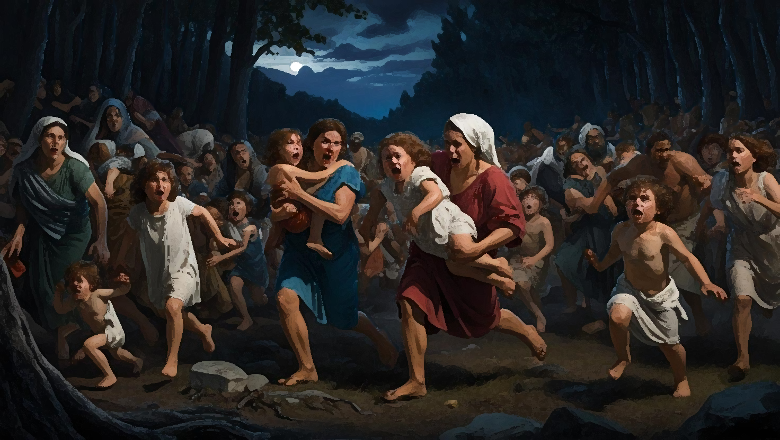

ChaPter 3 — A Mother’s Embrace
It is 1911 and after a grueling journey, Apostolos' five-year-old grandson Christos along with his son and daughter-in-law, Dionysis and Katerina, reached Preveza. The bustling port city offered little solace. Exhausted and hungry, they found shelter in a cramped, dilapidated house offered by distant relatives. But respite was fleeting.
Katerina, weakened by the journey and the gnawing fear, succumbed to a raging fever. Christos, clutching the small wooden cross that hung around his mother's neck, watched helplessly as she withered before his eyes.
One afternoon, as sunlight streamed through the grimy windowpanes, Christos sat by his mother’s bed, holding her frail hand. Her breaths came in ragged gasps. "Mama," he whispered, his voice thick with tears, "are you going to sleep?"
Katerina’s eyes fluttered open, a flicker of recognition in their depths. “Christos, my little one…” she rasped, her voice barely audible. “Come closer.”
He leaned in, his small hand enveloped in hers. A single tear traced a path down her cheek. "Mama," he asked, his voice trembling, "what's wrong?"
“I’m going on a long journey, Christos,” she whispered, her grip tightening, then loosening. "A beautiful place… I’ll always be with you… in your heart…”
Her eyes closed. Her breathing stilled. Christos, too young to understand the finality of death, continued to hold her hand, waiting for her to wake. The world around him blurred, the sounds of the city fading into a distant hum. Terror coiled in his small chest. A scream tore from his throat. The mother of Apostoli Koumboura heard the scream, run towards Christos and advised him to go and get his father.
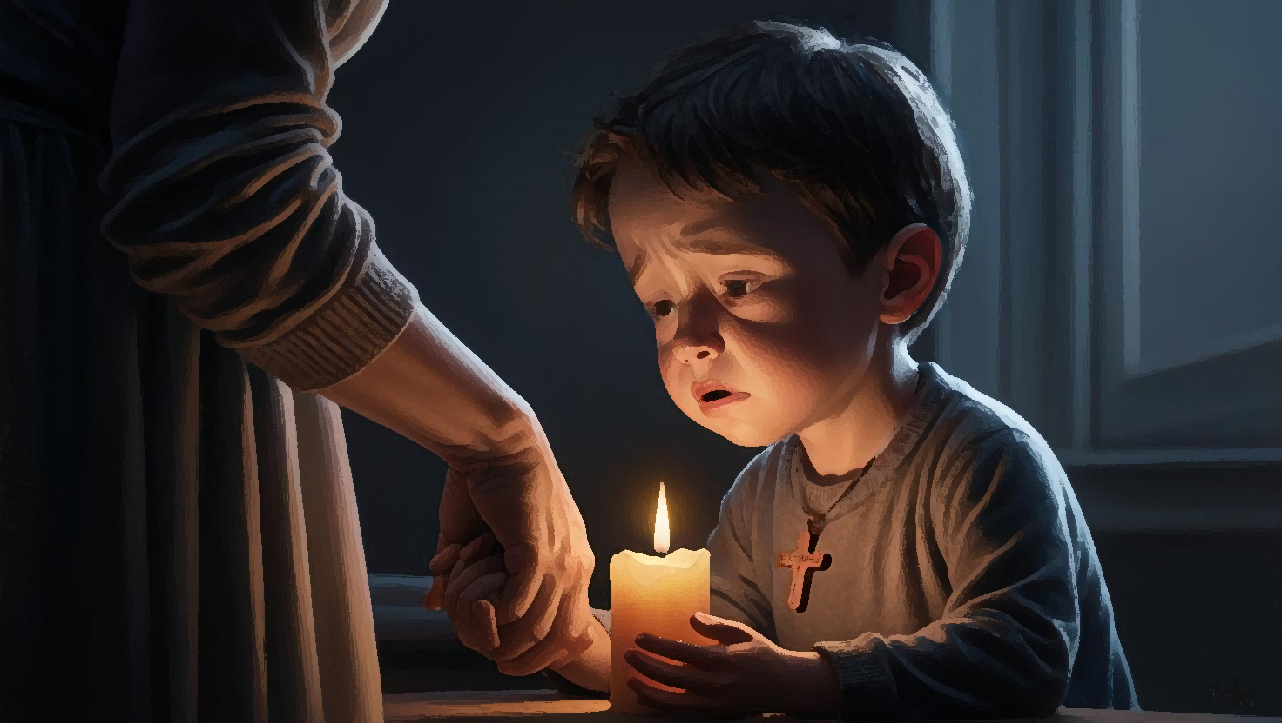

Chapter 4 — A Father's Legacy
The world felt strange and unfamiliar to Christos. Blurred faces. Hushed whispers. He clung to his mother’s wooden cross, its smooth surface a small comfort against his cheek. He didn’t see his mother buried, as he was sent to his uncles in Mytikas, only knew she was gone, on that “long journey.” He stayed with his uncles in Mytikas for a few weeks, lost in a fog of grief.
Returning to the empty house in Preveza amplified the emptiness within him. His father, Dionysios, a shadow of his former self, greeted him with a forced smile. Dionysios, his own health failing, knew his time was short.
One evening, after a visit from his aunt, Vasiliki Gioti, Dionysios called Christos to his bedside. He held his son’s small hand, his grip surprisingly strong. “Christos,” he began, his voice raspy, “there are things you need to know… about our family…”
He spoke of their ancestors, the Koutsonikas clan, their defiance against the Turks, their flight from Karakoli, the name change to Matsiras – “murderer.” He spoke of his brothers, scattered, their fates unknown.
"Find them, Christos," he urged, his eyes burning with a feverish intensity. "Vasilios in Kipseli… Ioannis in Xiromero, Parga, or Vonitsa… if you can. They are our family. Our connection to the past." A deep, rattling cough wracked his body. "Live a better life than I have, my son," he whispered, his voice fading. "Be strong. Be brave." He pulled Christos close, his embrace a mixture of love and despair.
Soon after, Dionysios succumbed to his illness, leaving six-year-old Christos adrift, a small boat tossed on a turbulent sea.
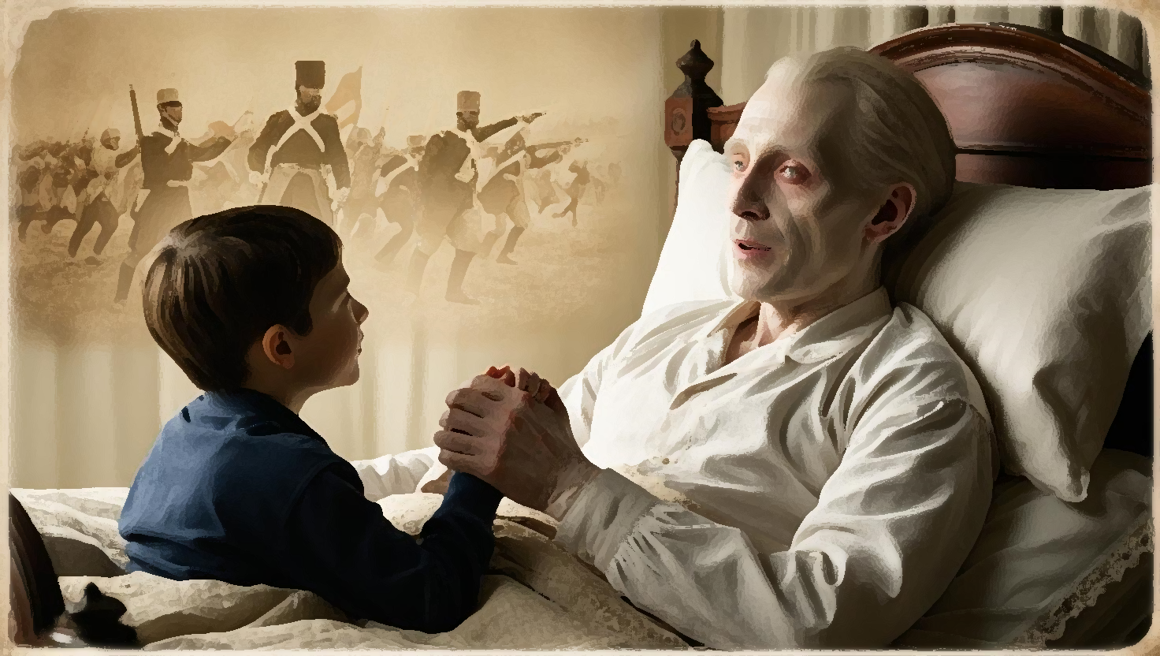

Chapter 5 — The Shadow of Mytika
Aunt Vasiliki, a stern woman with calculating eyes, arrived after the funeral, offering to take Christos to Mytika. Christos, yearning for family, any family, agreed readily. But Mytika was not the haven he craved.
Vasiliki, under the guise of guardianship, saw him as a means to an end – his small inheritance. She controlled his every move, rationing his food, forcing him to work long hours. He was a small servant, not a nephew. The memory of his parents’ love, their gentle touch, became a fading dream.
Driven by a desperate longing for his parents, he ran away one day, hiding under the school stairs, hoping they would magically reappear. The cold night brought only hunger and fear. He returned to Vasiliki defeated, shivering, his small adventure ending in a severe cold that threatened to extinguish his young life.
His cousin Vasiliki, and even Aunt Vasiliki herself, nursed him back to health, their ministrations a strange mix of begrudging care and self-interest. When he recovered, the thought of Preveza, his former home, tugged at his heart. He returned to find his parents' house locked and empty, a hollow reminder of his loss. The school steps, cold and unforgiving, became his refuge once more.

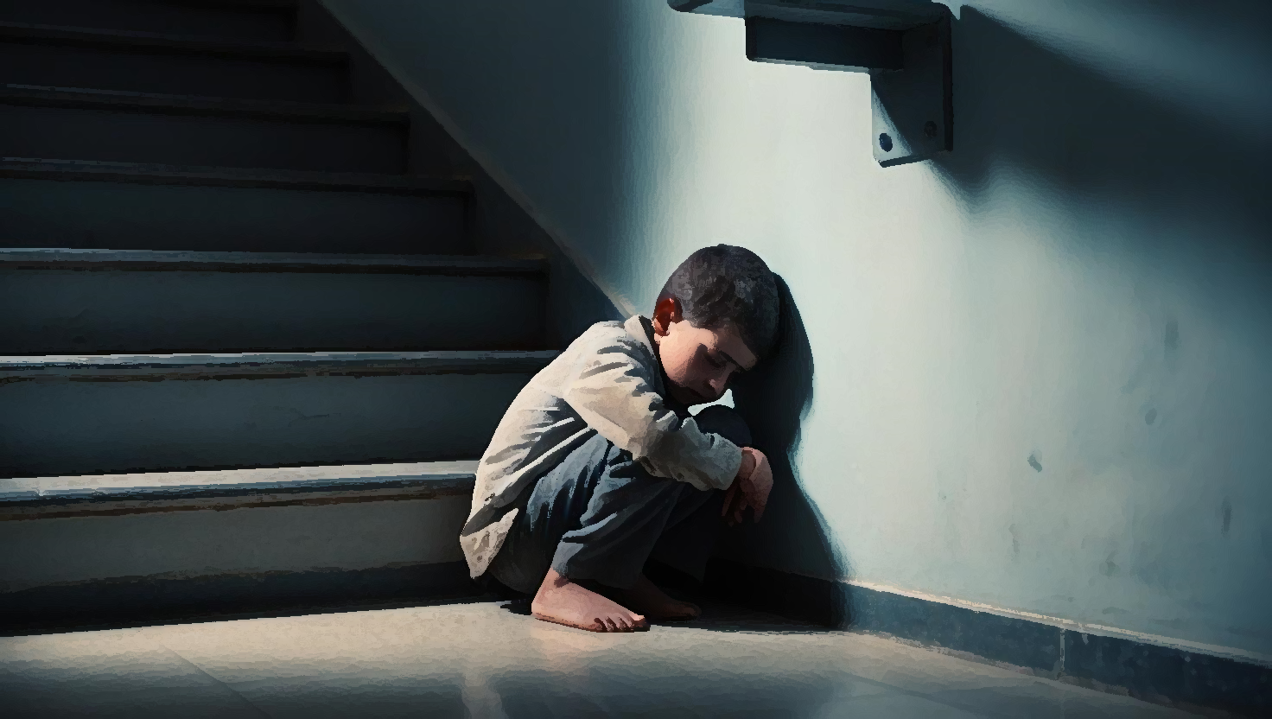

Chapter 6 — A Fleeting Kindness
Hunger gnawed at Christos’ belly as he wandered along the Preveza shore. The salty air stung his chapped lips. He was a small, solitary figure against the backdrop of the bustling port. Then, a familiar face emerged from the crowd – Karabetsos, his father's former employer, a portly man whose booming laugh Christos remembered from happier times.
"Dionysios’ boy! What are you doing here, lad?" Karabetsos’ voice boomed, a stark contrast to Christos’ quiet desperation.
Karabetsos’ wife, a kind-faced woman with gentle eyes, took one look at Christos and ushered him inside. A warm bath, clean clothes, a plate piled high with food – simple comforts that felt like unimaginable luxuries. For a brief time, Christos felt a flicker of hope.
He helped Karabetsos in his vast corn warehouse, the rhythmic rustling of the kernels a soothing balm to his frayed nerves. He found a small measure of purpose in the work, a temporary reprieve from the gnawing uncertainty of his life. But this fragile peace shattered when Turkish soldiers arrived, their faces grim, their demands uncompromising. They confiscated Karabetsos’ entire corn supply, leaving him bankrupt and unable to care for Christos any longer.
“I’m sorry, lad,” Karabetsos said, his voice heavy with regret, “but I can’t keep you anymore. I have nothing left to give.”



Chapter 7 — The Open Sea
Tears streamed down Christos’ face as he watched Karabetsos’ retreating figure. He was alone again, adrift. He found himself among a group of boatmen, their weathered faces and calloused hands testament to the harsh life of the sea. They ferried goods across the Ambracian Gulf, between Preveza and Koronisia, a lifeline connecting the scattered islands and coastal towns.
Yannis, a gruff boatman with a surprisingly kind heart, took pity on Christos. "Come on, lad," he said, his voice roughened by the sea wind, "I'll take you to Koronisia."
Koronisia, a bleak, desolate island, offered little refuge. Christos, practically naked and starving, wandered the beaches, the salty wind whipping at his thin frame. He retched with hunger, his dreams filled with images of warm bread and the comforting hum of a classroom. The fishermen, hardened by their own struggles, were mostly indifferent to his plight.
Then, one day, an old woman, Maria Rapti, her face as weathered as the driftwood scattered along the shore, stopped to talk to him. She saw the yearning in his eyes, his desperate desire for something more. She couldn’t offer him education, but she could offer him work. “Come, boy,” she said, her voice raspy but not unkind, “you can tend my goats.” It wasn’t much, but it was a roof over his head and the promise of food.
On a trip with the goats, little Christos stepped on a piece of wood with a nail, which pierced his foot. A wound quickly developed, but thanks to the timely intervention of the mother of a childhood friend with whom little Christos used to fish and the wife of a local priest (Papa-Kitsou Katsantonis), he escaped tetanus. It was another stepping stone in his young life, another lesson in resilience in the face of adversity.
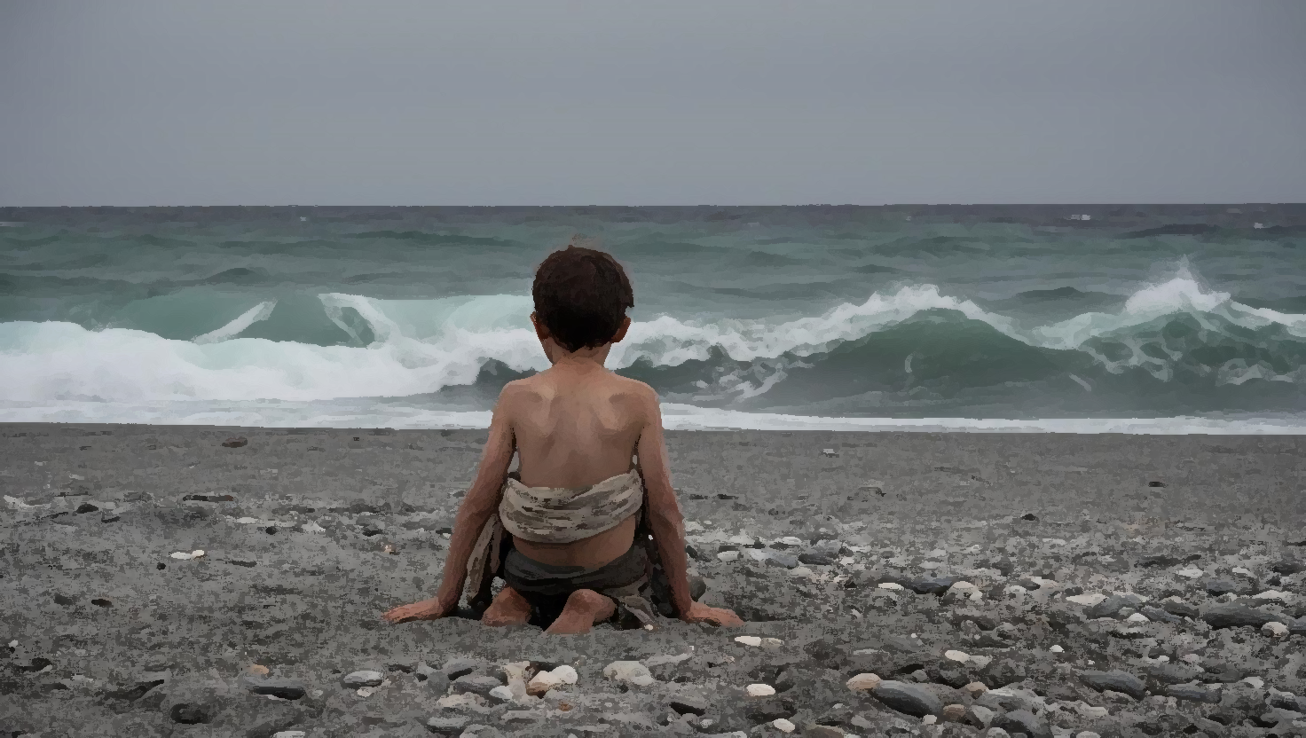

Chapter 8 — The Fish Farm's Solitude
Life with Maria, while providing basic necessities, was a lonely existence. One day, she suggested Christos seek work at a fish farm in Xiromero, overseen by a solitary old man named Vasilis.
The fish farm, isolated and exposed to the elements, became Christos’ new world. The biting wind whipped across the open water, the cries of seagulls a constant soundtrack. He learned the intricacies of the trade, the rhythm of the tides, the silent language of the sea. Old Vasilis, in his gruff way, taught him the skills he needed to survive. But his temper was as unpredictable as the sea itself.
One afternoon, a disagreement over the sorting of fish for a customer, Giorgos Paliambelos, escalated into a violent outburst. "You stupid boy!" Vasilis roared, his face contorted with rage. He hurled a stone at Christos, striking him in the head. Blood welled up, a crimson stain against his pale skin.
Paliambelos, witnessing the incident, intervened, his voice sharp with reprimand. "Vasilis! What are you doing? He's just a boy!" He tended to Christos’ wound, his touch gentle and reassuring. This small act of kindness, a spark of humanity in the desolate landscape, offered Christos a glimmer of hope. But that night, old Vasilis’ rage returned, and he beat Christos mercilessly, leaving him bruised and broken.
Another time, old Vasilis gave a bottle of ouzo to little Christos to take to Giorgos. On the way, however, little Christos stumbled and fell under the weight of the bottle. As he fell, he broke the bottle. Knowing what awaited him from old Vasilis, he burst into tears in the middle of the road. Paliambelos saw him and told him not to worry. To comfort him, he even gave him another bottle.
Unfortunately, old Vasilis was not at all satisfied and beat little Christos very badly that night, so much so that he remained ill in bed for quite some time. Through a shepherd, Nasos Matsoutsos, Giorgos Paliambelos learned about little Christos' situation and immediately contacted the owners of the fish farm, who fired old Vasilis.
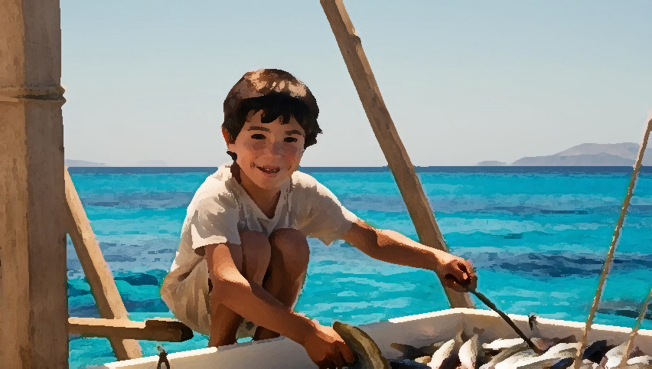

Chapter 9 — Bandits and Bargains
The fish farm's isolation made it a haven for bandits – notorious figures like Zamagoulis, Katselis, and Mavrakadis. Christos, privy to their clandestine visits, learned to navigate this dangerous world. He had a place to work, but not to sleep. He slept under bushes, seaweed his only bedding, hoping to avoid unwanted encounters.
One night, his luck ran out. A group of bandits discovered him, their faces masked by shadows, their weapons glinting in the moonlight. "Fish, boy!" one growled, his voice menacing. Fear choked Christos, but he stood his ground.
To his surprise, their leader, a man with piercing eyes and a surprisingly gentle voice, intervened. "Leave him be," he commanded. He even shared some of their grilled meat with Christos, the smoky aroma filling the night air.
Later, they offered him 25 drachmas to buy them wine from a nearby village (Paliambelo) and get intelligence on troop movements. It was a risky proposition, venturing out alone at night, but Christos had little choice. He made his way through the darkness, whispering prayers to Saint Giorgos, his heart pounding in his chest.
Christos, having no other choice, reached the village at night and without lights, among the grass and bushes. He approached the tavern, where, according to the instructions he had received, he threw stones at the tavern owner’s window to wake him up and then asked him for wine and information about the location of the military detachment.
Indeed, the tavern owner gave him wine and informed him that the detachment was in the village of Saint Basil and was heading to Rouga. Christos carried out his mission and brought the wine and information to the bandits, who after thinking about it gave him the 25 drachmas. With this money, little Christos went to Vonitsa, where he bought new clothes and threw away the old ones that were full of lice.
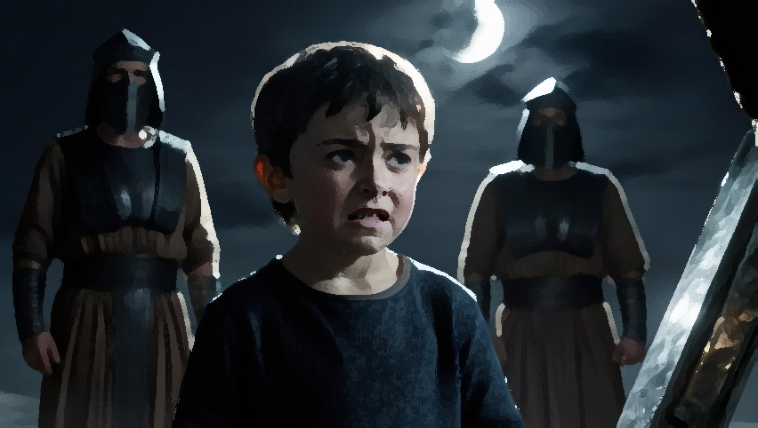

Chapter 10 — An Empty Feast
Life at the fish farm continued its monotonous rhythm, punctuated by the occasional visit from fishermen collecting their harvest. Christos, largely ignored, performed his duties diligently, yearning for connection and recognition.
On the feast of the Fifteenth of August, the fishermen asked him to fetch bread from Savva Kolovou, the fish farm owner's daughter. Savva, though annoyed at the request, gave him the bread. Christos brought the bread to the fishermen, who, indifferent, gathered their gear and left, their indifference a stinging blow.
Fasting and dejected, he sat alone, the uneaten bread a mocking reminder of the feast day. Just then, Panos Paloukis, a shepherd, who together with his brothers owned a flock of two thousand sheep, arrived, seeking fish. Christos, seizing the opportunity, proposed a barter – fish for bread and dairy.
The deal was made with Paloukis’ threshing floor the meeting place, where he would tie up the dogs and wait for Christos. Little Christos, without wasting time, took a small boat and went near the edge of the fish farm, from where he risked entering the forbidden area of the fish farm, He swam to collect a hefty catch around five kilos of fish and took them to the shepherd’s threshing floor.
When he arrived there, the shepherd shouted at him to stop, but Christos did not hear and continued, causing the dogs in the barn to rush at him. Stunned, Christos was wondering what to do, when the shepherd called to him to sit down. Indeed, little Christos sat down and the dogs came around him. The shepherds tied up the dogs and Christos gave them the fish.
The shepherds, impressed by his bravery and resourcefulness, rewarded him with bread, milk, and cheese. It was a small victory, a testament to his growing resilience and his ability to create opportunities in the face of adversity.
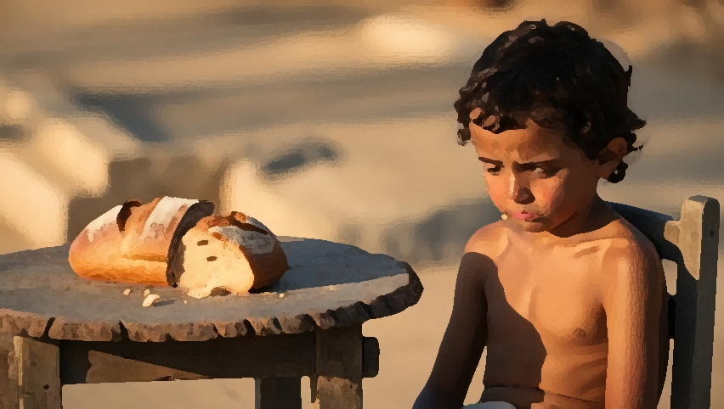

Chapter 11 — A Fish Story
A month later, the fishermen returned. They found Christos tending the replenished fish farm, a mixture of relief and suspicion in their eyes. "So, boy," one said, his voice gruff, "where were the fish last time?"
Christos, no longer the timid child, met their gaze directly. He recounted his tale – their indifference, his hunger, the desperate barter with the shepherd. Instead of anger, a grudging respect flickered in their eyes. They recognized in him a resourcefulness born of necessity, a reflection of their own struggles. He was no longer invisible, his value finally recognized.
He found companionship with Nasos Matsoutsos, a widowed cowherd, and his two children. They shared meals of freshly caught eels, cooked over crackling winter fires, their stories weaving a tapestry of hardship and resilience. Sometimes, other fishermen would join them, their laughter echoing in the night. Sometimes, they would steal Christos’ eels, leaving him with nothing but embers and the bitter taste of betrayal.

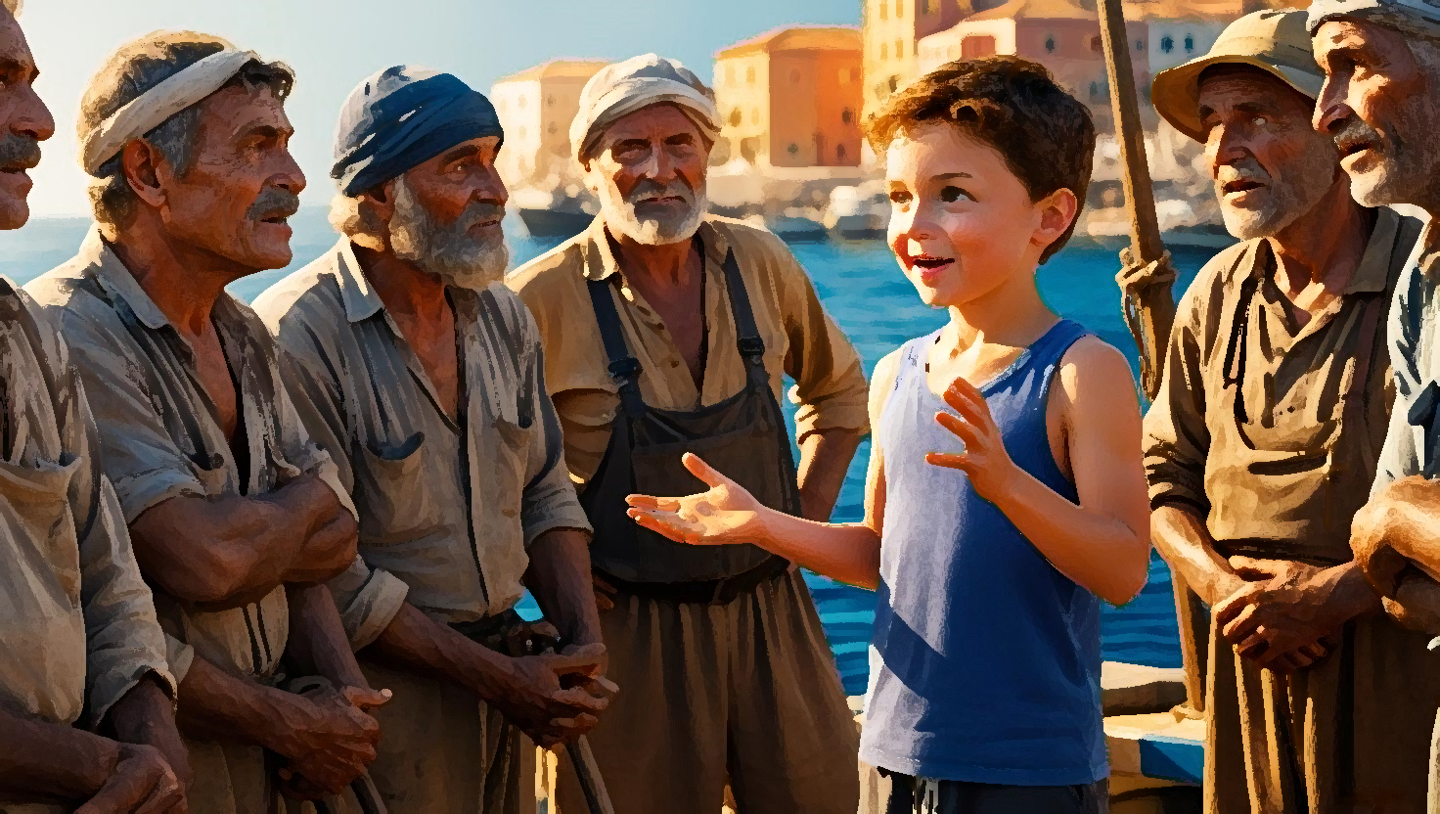

Chapter 12 — A New Family
News arrived from Koronisia – a family seeking a stepchild. Greece, under Allied blockade, faced hardship. Families struggled. Christos, remembering Aunt Vasiliki’s exploitative “care,” hesitated. But the lure of a stable home, the possibility of school, was too strong.
Gakis Kotsis and his wife welcomed him with open arms. Their small vineyard offered a modest living, but their home offered something far more valuable – warmth, belonging, a sense of family he had long craved. They clothed him, fed him, treated him as their own. But their meager resources couldn't sustain them all. After a year, they arranged for Christos to work at Christos Panelis’ fish farm in Katavrocho.

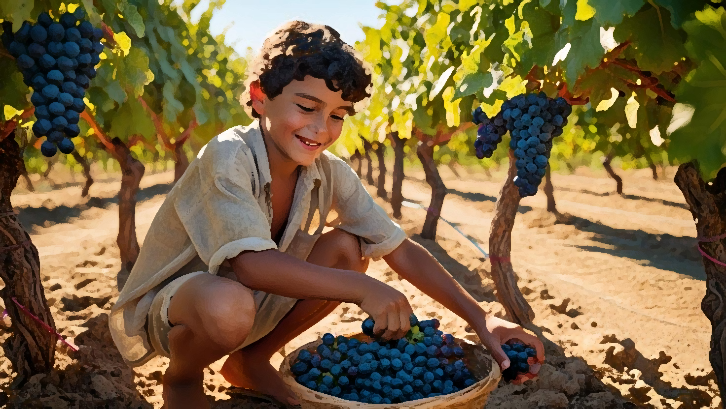

Chapter 13 — Finding Purpose in Work
At the Katavrocho fish farm, a semblance of peace settled over Christos. He had a roof over his head, regular meals, a small salary of 25 drachmas. He prayed for strength, for health, for growth, determined to overcome the hardships life threw his way. He embraced every task, from fetching water by horseback from nearby Anoxiatikos village to baking bread and cooking for the fishermen.
His dedication didn't go unnoticed. When Panelis' son was conscripted after the Asia Minor Catastrophe, the fish farm faced a dilemma. They couldn't afford another worker. They offered Christos a raise to 75 drachmas, entrusting him with greater responsibilities. He accepted, his heart swelling with a quiet pride. He was proving his worth.
One day, his stepfather arrived in a sailing boat, a hesitant look on his face. "Christos," he began, "I need 100 drachmas… to buy a field." Christos, his savings growing steadily, didn’t hesitate. "Here's 200," he said, "100 for the field, and 100 for you and Mother."

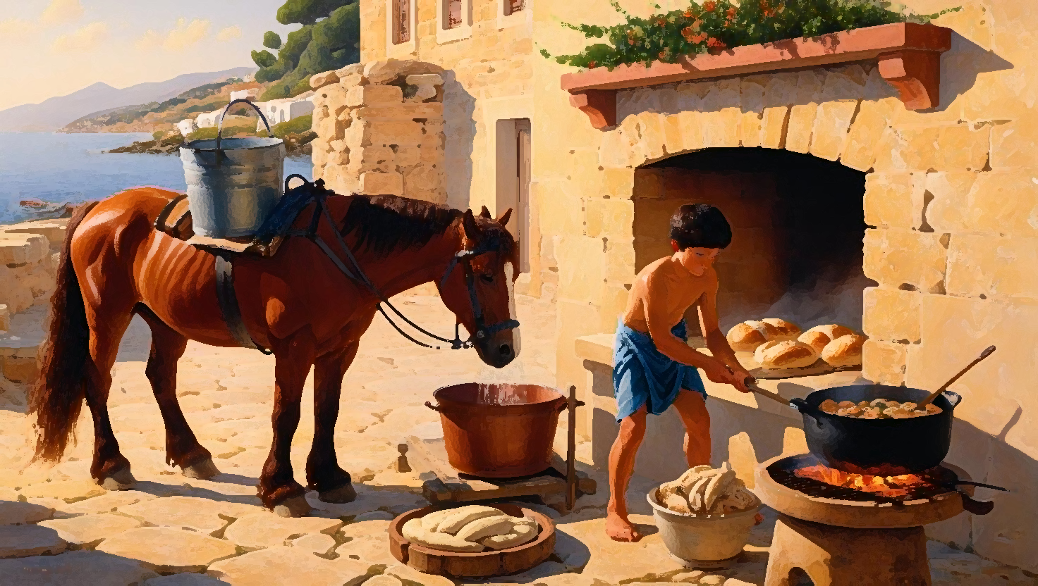

Chapter 14 — A Boat and a Betrayal
When Gakis died, he left Christos his boat. This unexpected inheritance opened up new opportunities. Christos began transporting rushes for Spyros Kontogiannis, a merchant supplying Italian ships. Kontogiannis, impressed by Christos’ efficiency and honesty, paid him well (150%), eventually making him foreman.
The profits of 500 drachmas from this venture allowed Christos to buy his own land. He approached his stepmother, offering to take her with him. She refused, preferring to stay in her familiar surroundings. Despite her refusal, she urged her brother, Yannis Kassais, to help Christos find suitable land. Yannis found a plot in Martinia, near Neochori, for 800 drachmas. Christos bought it, his heart filled with a sense of accomplishment.
He was building a future, rooted in the land, a testament to his unwavering perseverance. He later acquired more land in Neochori, each purchase a step towards security and independence. The challenges of land ownership – clearing fields, building furrows – were daunting, but they were his challenges, a mark of his progress.

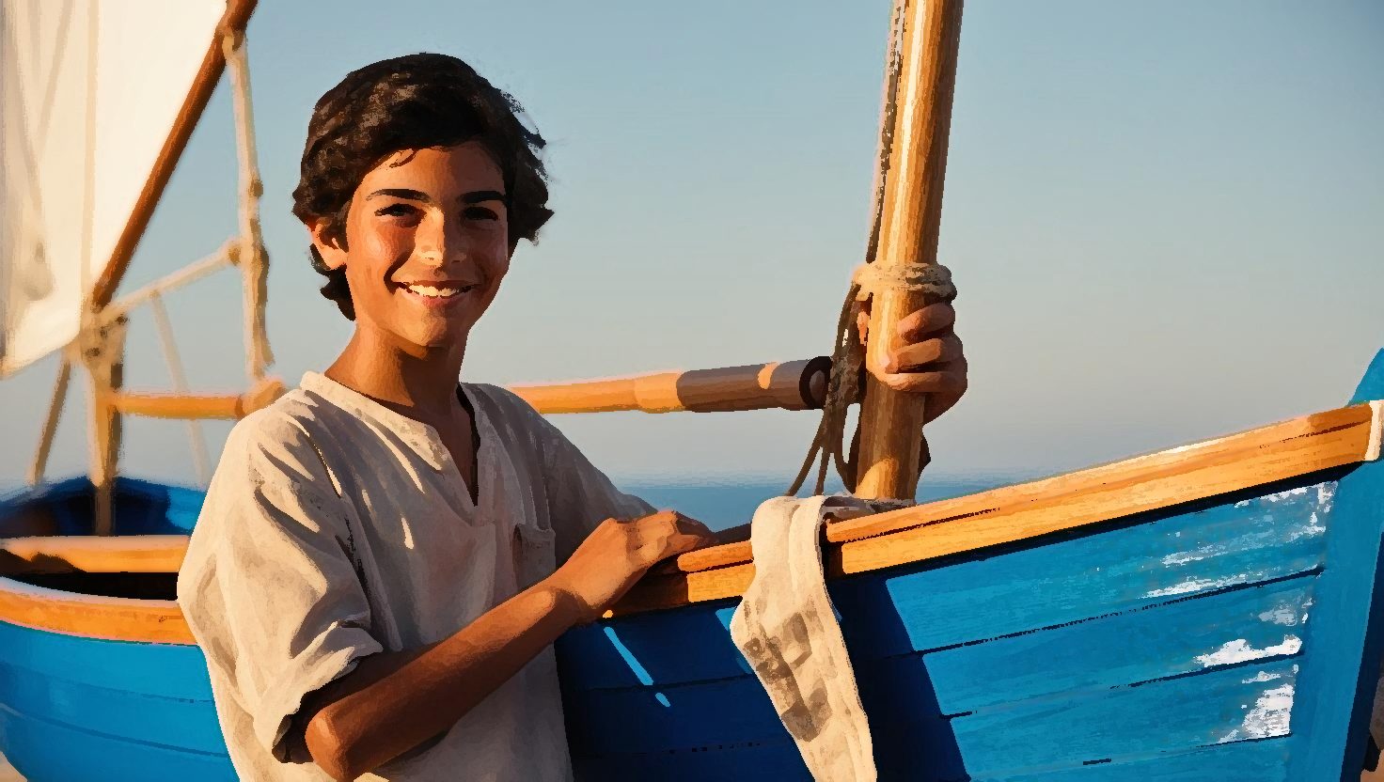

Chapter 15 — Smuggler's Run
Theodoros Moraitis, an olive oil and corn smuggler from Lefkada, approached Christos with a risky proposition: transport his illicit cargo across the Ambracian Gulf to Kopraina. The reward was substantial, but the danger was palpable.
A fierce storm erupted mid-journey. The small boat bucked and pitched, the waves crashing over the deck. Moraitis and his men, seasick and terrified, huddled below, their faces green. Christos, his hands gripping the helm, fought to control the sails, navigating the treacherous waters with a skill honed by years at sea.
“We’re going to die!” Moraitis moaned, his voice barely audible above the roaring wind.
Christos, his jaw set, his eyes fixed on the distant shore of Bouka, a safe haven, wrestled the boat towards shelter. He then continued on to Kopraina, as instructed by Moraitis.
At Kopraina, he faced the customs officials. "Why are you here?" they demanded, suspicion lacing their voices.
"Found these fishermen in distress," Christos lied smoothly, as instructed by Moraitis. "Their boat was taking on water. Helped them bring their cargo ashore."
The officials, already bribed, accepted the story without question. The smuggled goods were unloaded, and Christos received his payment – 500 drachmas. He had navigated not just the treacherous waters of the Gulf, but also the murky world of illicit trade. The weight of the coins in his hand was a tangible measure of his risk, and his success.


Chapter 16 — A Quiet Act of Courage
Christos, now a landowner, faced new challenges. He hired workers, including the loyal Giorgos Gogalis, to cultivate his fields. As he built his fortune, the world outside descended into the darkness of the Balkan Wars. The shadow of death loomed large. Many locals faced imminent danger.
Christos, despite the risks, used his intimate knowledge of the Ambracian Gulf’s hidden coves and inlets to ferry refugees to safety. Under the cover of darkness, he guided families huddled in his small boat, their whispered prayers mingling with the gentle lapping of the waves. He saw the fear in their eyes, the desperation etched on their faces, the silent gratitude they offered as they reached the safety of the opposite shore. He worked quietly, without fanfare, driven by a deep compassion and a belief in the inherent worth of every human life. His silence was a testament to his humility, his understanding of true courage.
Living with his stepmother and working hard, the now eighteen-year-old Christos has made a small fortune from land and 19 cows. Unfortunately for him, his stepmother becomes more and more strange and demanding as time goes by. One of her wishes is for Christos to marry. Indeed, Christos married one of the daughters of Lambros Safakas, Christina. With a pregnant wife, Christos enlists in the Army and presents himself in Ioannina as a scout nurse.

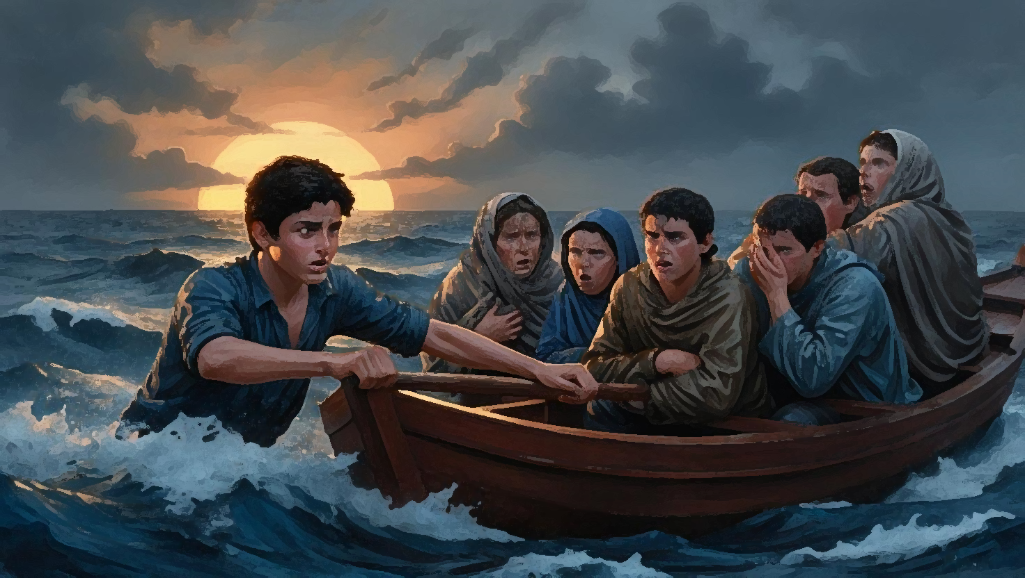

Chapter 17 — War and Worry
At eighteen, Christos was conscripted. Life as a scout nurse was a harsh awakening. The stench of antiseptic filled the air, mingling with the moans of the wounded. He witnessed the callous indifference of some officers, their humanity seemingly eroded by the horrors of war. This starkly contrasted with the compassion he felt for the suffering men under his care.
While on a mission, his horse threw him, then turned and lashed out, its hooves striking his side. The wound festered, a raging fever consuming him. Dr. Pritsos, known for his harsh demeanor, dismissed Christos’ suffering with a wave of his hand. "Stop malingering, soldier!" he snapped. Despair washed over Christos, the pain amplified by the doctor's indifference. He contemplated ending it all, the darkness beckoning.
Another doctor, witnessing his deteriorating condition, intervened, ordering his transfer to a military hospital. On Saint Dimitrios’ feast day, he underwent surgery, clinging to the fragile thread of hope. But as he battled for his life, a telegram arrived at the camp, bearing news that would shatter his world.

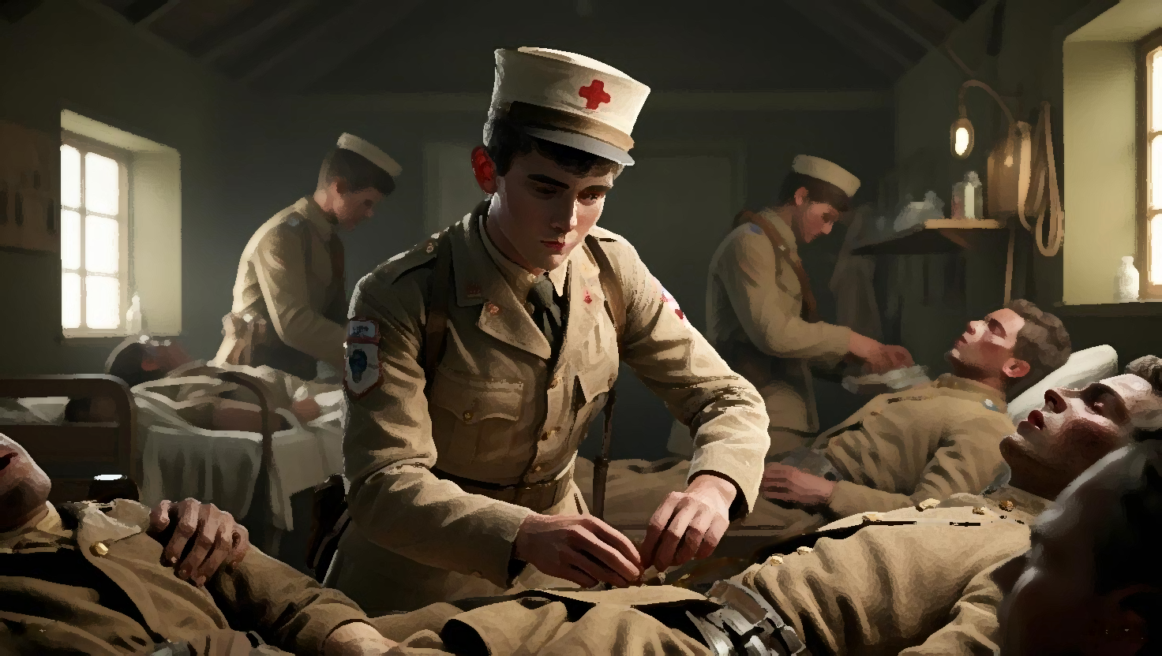

Chapter 18 — A Double Blow
Christos’ commanding officer held the telegram, his face etched with concern. He wrestled with how to deliver the devastating news: Christina, Christos’ pregnant wife, was dead. He granted Christos immediate leave, a small act of mercy in the face of such profound loss.
Christos, still recovering from surgery, remained oblivious to the storm raging outside the hospital walls. He learned later the cruel irony: on the very day of his operation, Christina, while fetching water from the river, had slipped and drowned.
Upon his release, his commander exempted him from duties, allowing him time to heal. He existed in a haze of grief, the world a muted landscape. Then, Zikos, a villager from the Arta plains, a face from his past, gently broke the news. He learned that his fellow soldiers, Yiannis Ragkos and Kostas Chalkias, had known, had withheld the truth, hoping to spare him further pain.
Anger, raw and visceral, surged through him. But the rage was short-lived, replaced by the crushing weight of his double misfortune. He returned Christina’s dowry to her family, ensuring her sisters could have the opportunity for a better future, a small act of kindness in the face of his own overwhelming grief.

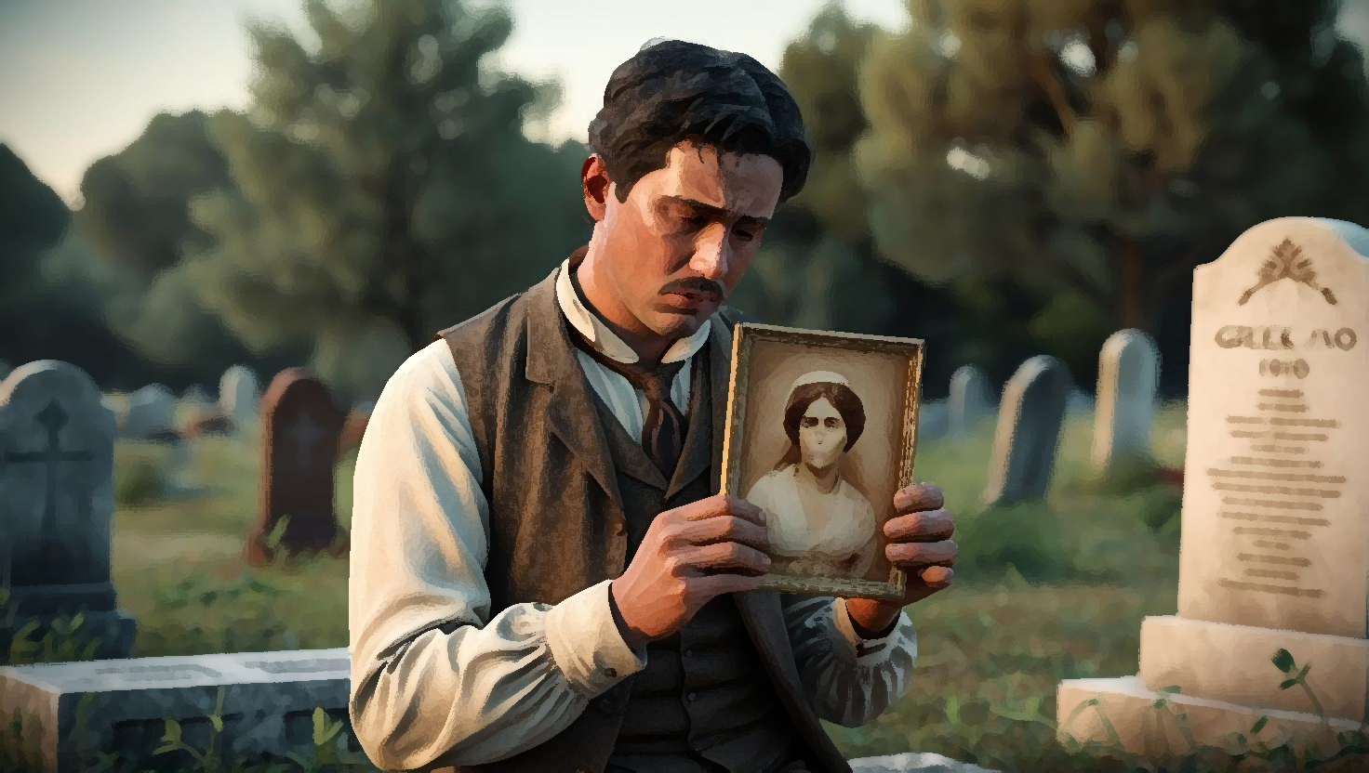

Chapter 19 — A New Beginning
After his discharge, Christos sought solace in the familiar rhythms of the sea. Giorgos Tsakmakis, his friend, sensing his profound loneliness, arranged a meeting with Athena, one of Fotis and Maria Pani’s seven daughters.
Christos remembered a strange incident in the army. He’d read his horoscope in Kazamias magazine, predicting a wedding. He'd dismissed it then, already married. Now, the prediction seemed eerily prescient.
He wasn't immediately drawn to Athena. She was thin, unassuming, not fitting the conventional beauty standards of the time. He questioned her strength, her ability to withstand the hardships of their married life. But her father assured him of her resilience, her quiet strength. Giorgos vouched for her character. The match was made, a dowry of 3,000 drachmas sealing the deal. A new chapter began.

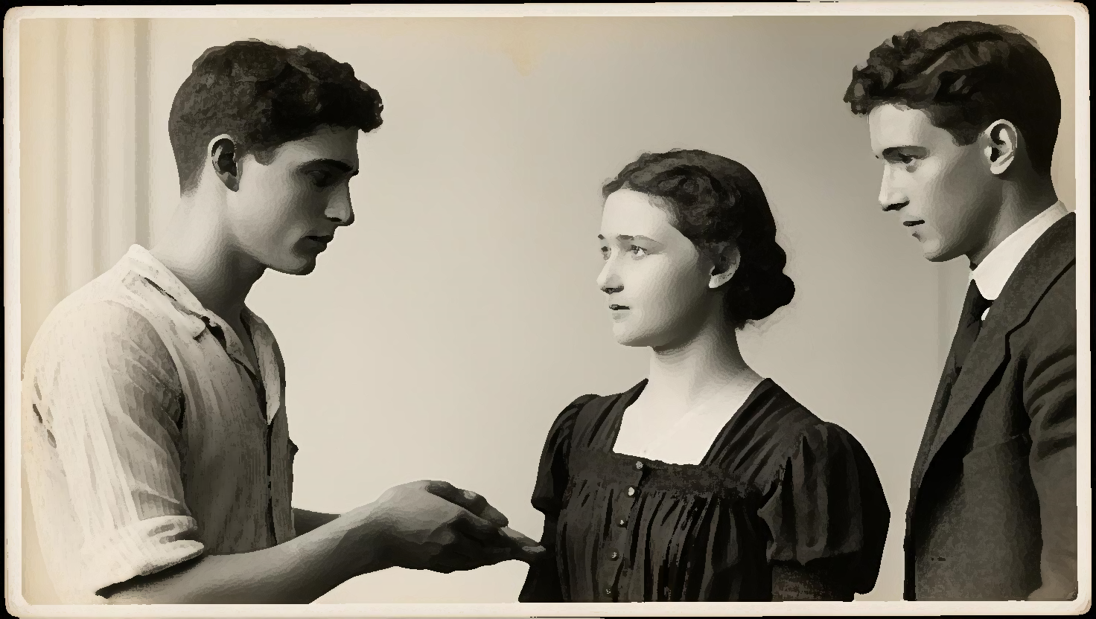

Chapter 20 — Family and Future
Christos and Athena’s marriage blossomed, bearing fruit in the form of six children: Vasilios, Theodora, Giorgos, Christina, Eleni, and Emmanuel. Despite the hardships of postwar Greece, Christos ensured his sons received a good education, pushing them towards higher learning. He provided generous dowries for his daughters, securing their future.
He instilled in them the values forged in the crucible of his own life: hard work, honesty, respect. He taught them resilience, perseverance, the unwavering belief in a better future. He shared stories of his own challenging journey, not as tales of woe, but as testaments to the indomitable strength of the human spirit.

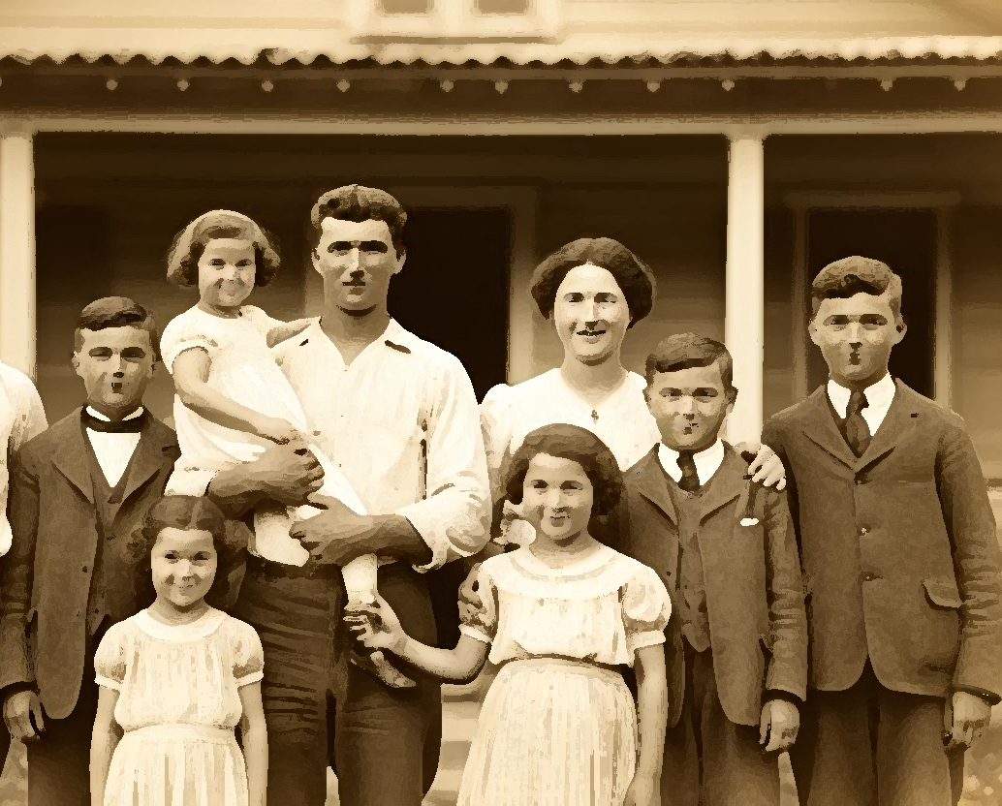

Chapter 21 — A Legacy of Strength
Christos lived a long life, nearly eighty years plus, in Neochori, near the place of his birth. He remained fiercely independent, refusing charity, his pride a reflection of his self-reliance. He found contentment in his family, his legacy etched not in grand achievements, but in the quiet strength and unwavering values he instilled in his children.
I, the writer, interviewing him on December 26, 1986, was struck by his unwavering spirit, his quiet dignity. His story, a testament to resilience, perseverance, and compassion, reminds us that true strength lies not in the absence of hardship, but in the ability to overcome it, to rise from the ashes, to build a life filled with purpose and meaning. His final wish was simple: that his descendants carry the torch of his struggle into their own future, continuing the fight for a better life, a better world.

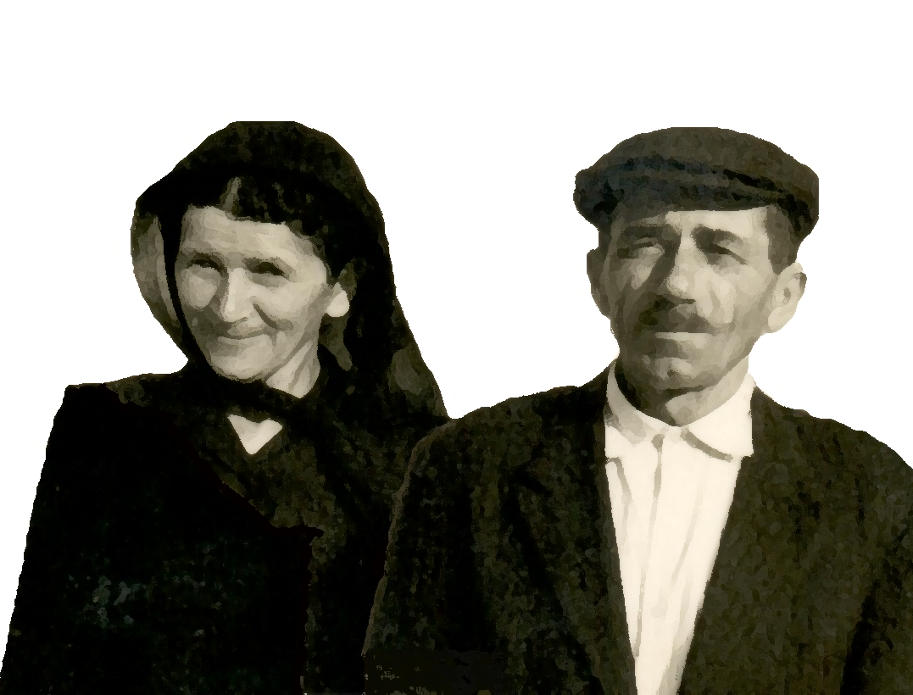

Timeline of People and Locations
- Early 1800s (approx. 1803-1826):
  - People: Koutsonikas/Matsiras family (Nikolaos, Vasilios, Apostolos, Ioannis), Gerokostas family, Markos Botsaris (mentioned)
  - Places: Epirus mountains, Zaloggo, Parga, Messolonghi, Souli, Karakoli
- 1826 (approx.):
  - Event: Flight from Karakoli after Ottoman attack
  - People: Nikolaos, Vasilios (with son Dionysis), Apostolos (with wife and infant son Dionysis), Ioannis
  - Places: Kipseli (Tourkopalko) - Vasilios flees here; Preveza - Apostolos flees here; Xiromero, Parga, or Vonitsa - possible locations for Ioannis
- 1911:
  - People: Christos (grandson of Apostolos, son of Dionysis and Katerina), Dionysis, Katerina, Apostoli Koumboura (neighbor in Preveza), Vasiliki Gioti (aunt in Preveza)
  - Places: Preveza, Mytikas
- After 1911 (Childhood Years):
  - People: Christos, Vasiliki Gioti (aunt/guardian), Karabetsos (father’s former employer and his wife), Yannis (boatman), Maria Rapti (goat herder in Koronisia), Papa-Kitsou Katsantonis (childhood friend), Nasos Matsoutsos (shepherd), Giorgos Paliambelos (fish customer), Vasilis (abusive fish farm overseer), Zamagoulis, Katselis, Mavrakadis (bandits), Savva Kolovou (fish farm owner’s daughter), Panos Paloukis (shepherd), Giorgos Gogalis (farm worker), Spyros Kontogiannis (merchant), Yannis Kassais (stepmother’s brother), Theodoros Moraitis (smuggler)
  - Places: Preveza, Mytika, Koronisia, Xiromero, Paliambelo, Vonitsa, Saint Basil, Rouga, Anoxiatikos, Katavrocho, Martinia (near Neochori), Neochori, Ambracian Gulf, Kopraina, Bouka, Lefkada
- 1912-1913 (approx. during Balkan Wars): Christos ferries refugees across Ambracian Gulf.
- Adulthood (approx. 1914 onwards):
  - People: Christos, Christina (first wife, daughter of Lambros Safakas), Dr. Pritsos (army doctor), Zikos (villager from Arta plains), Yiannis Ragkos, Kostas Chalkias (fellow soldiers), Giorgos Tsakmakis (friend), Athena (second wife, daughter of Fotis and Maria Pani), Vasilios, Theodora, Giorgos, Christina, Eleni, Emmanuel (Christos and Athena's children), Interviewer (writer)
  - Places: Ioannina, Arta plains, Neochori

